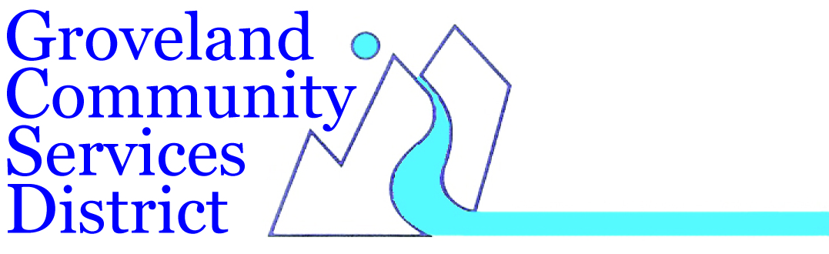

GCSD TO OPEN COMMUNITY RESOURCE CENTER

DURING PG&E PUBLIC SAFETY POWER SHUTDOWN (PSPS)

In the event of a PG&E power shutdown as predicted for early Wednesday morning, the Groveland Community Services District (GCSD) is establishing a location at the GCSD office parking lot where people affected by the power outage can access the internet, charge electronic devices and receive current information about the power outage. This community service will be provided outside the GCSD office located at 18966 Ferretti Road, during office hours throughout the power outage.
Those on groundwater wells and without power in the community will be able to fill water bottles and containers with tap water, to allow for flushing toilets, bathing and other sanitation needs. Since GCSD will not be providing the water containers, those receiving water should treat it as non-potable.
Stay tuned to www.gcsd.org or our Facebook page for updates, and call the office if you have any questions; (209) 962-7161.

